Staining equipments:
Various staining equipments used in laboratory are as follows:

Five-Slide Gripper:
- The 5-Slide Gripper accommodates 5 microscope slides in one staining procedure
- It fits most coplin and round-open staining jars
- It is made from a special material which is resistant to all chemicals and solvents which are used in staining
- There is no need to remove slides for drying
- It withstands drying temperatures up to 80°C.
- 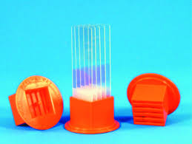

Glass Coplin Staining Jar, Screw Cap:
Holds 5 single 1" x 3" slides vertically, or 10 slides back-to-back. Slides extend above the opening, allowing for the manipulation of them without the use of forceps. A screw cap has a metal foil liner that withstands stains and organic solvents and it prevents evaporation.
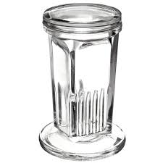

Cover Glass Staining Rack:
For staining, clearing and dehydrating cover glass preparations
This cover glass trough features 12 equally spaced grooves which will support round or square cover glass sizes 18, 22, 25, 50 mm, as well as standard rectangular cover glasses up to 22 x 32 mm size.
- The alumina rack is designed to be stable with its 90° V-trough with an 8 mm open slot at the bottom
- Designed for use with iron alum and other solutions that corrode metal racks.
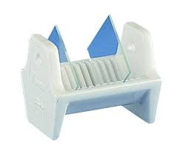

Wash-N-Dry Slide Rack:
Maximum Circulation Offset design allows liquid and air to completely flow around the entire slide ensuring cleanliness and faster drying times.
"Hands Off Design" Tailored to contact a minimal amount of slide surface area permitting solutions and air to affect entire slide.
Holds 12 Slides Securely holds slides for convenient cleaning, treating, staining, and drying
Laboratory Friendly Utilizes chemically and thermally resistant glass infused polypropylene. Autoclavable!
Create A System Use in conjunction with a 200 ml tall form beaker to efficiently use solutions.
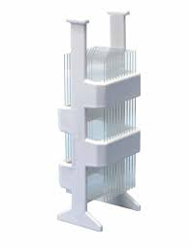

Slide Staining Jar, Round:
Made from polypropylene, holds 10 slides, back-to-back. Designed in a round shape and short body to conserve space and staining solution. When the cap is removed the slides can be handled without touching the solution. The screw cap has a locking recess to support the slides and both body and cap have a molded-in lug to enable them to be wired together for transit.
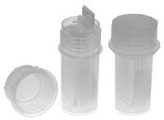

Schifferdecker Staining Jar:
Soda lime glass staining jar, resists staining from Eosin or Hematoxylin.
This jar comes with glass cover to reduce stain evaporation.
Holds 10 slides back-to-back horizontally.
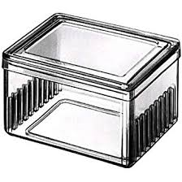

Immuno Stain Moisture Chamber:
Each moisture chamber is divided into ten individual compartments with approximately half-inch empty space between the compartments. When the chamber lid is closed, eight barrier dividers are placed into the empty spaces between the microscope slide compartments completely isolating all compartments. This is a very desirable feature when doing immuno staining.
The microscope slides are placed on four pedestal posts and four corner posts each 0.460 inch (11.5 mm) high thus raising the surface of the slides approximately half-inch off the floor to keep the slides away from the water below and to make the slides easily retrievable (either by hand or by forcep).
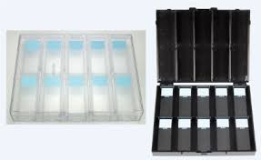
The chamber is fabricated out of heavy-duty polystyrene with an air-tight design to keep moisture in. The chambers are designed to be stackable in order to save counter and/or refrigerator space.

